|  |  |  |  |
| --- | --- | --- | --- |
| What Students Learn in this Program | | | Certifications |
| Prerequisite: DIT |  | Digital Info Tech | Word Press |
| Foundations of Programming | HTML/CSS & Intro to JavaScript | Coding basics, design thinking process, flowcharts; labs & Career-oriented focus | Info Technology Specialist- HTML/CSS |
| JavaScript Programming | JavaScript & Intro to Python | Block based coding, extensive programming in JavaScript; Portfolio & Ecommerce Site work | ITS - JavaScript |
| Procedural Programming | Python & Responsive Design | Interactive Coding & Navigation, Site Maps Responsive Design; Project & Portfolio work | ITS –Python |
| Object-Oriented Program Fundamentals | HTML/CSS  HTML5 | Script Programming in a Visual Studio Integrated Data Environment | ITS – JavaScript & Intro to HTML5 App Dev Fd |
| Web Programming | HTML & CSS | Web Labs, Storyboards, Launch/Maintain ISTEM Ecommerce website | ITS - HTML5 App Dev & Computational Thinking |

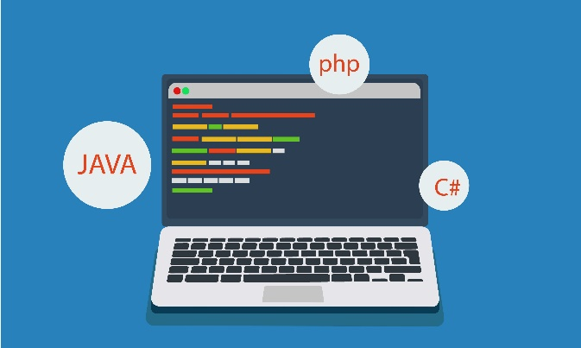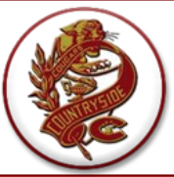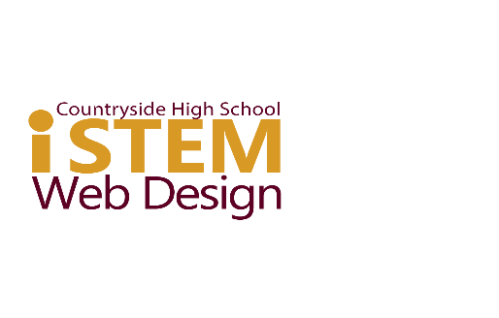

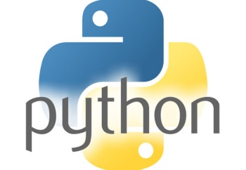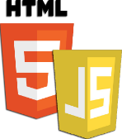

[This Photo](https://rolandocaldas.com/html5/como-incluir-javascript-en-html5) by Unknown Author is licensed under [CC BY-SA-NC](https://creativecommons.org/licenses/by-nc-sa/3.0/)

*In this CHS ISTEM Strand advance your programming skills and knowledge to prepare you for some of hottest in-demand career fields as you pass Industry Certifications & build a Digital Portfolio! Be ready to create websites & web apps like professionals do for Ecommerce, Retail & Wholesale industries & more.*

**WEB APPLICATION**

**DEVELOPMENT & PROGRAMMING**

**Julie Yaeger - yaegerj@pcsb.org**